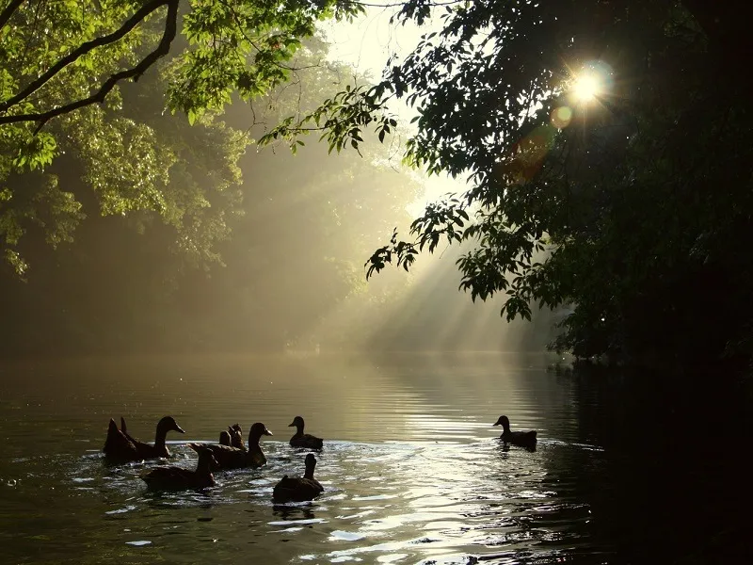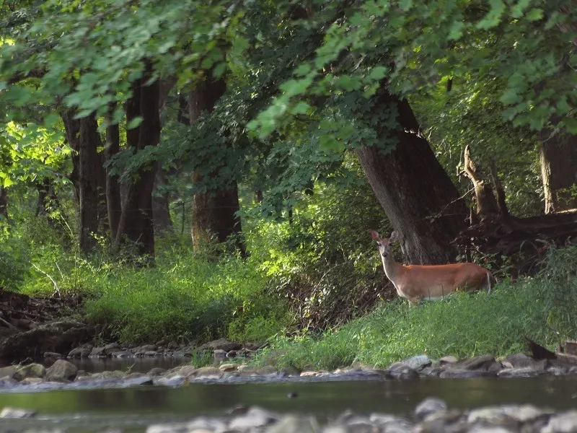
February 12th & February 26th, 7:30 pm
Franklin Township Municipal Building
2093 Rt. 57
Broadway, NJ 08808

What does the Musky mean to you?
A proposal to tear up productive farmland across from the Musconetcong River in Warren County and replace it with a 1.2 million sq. ft. warehouse plus 2.3 million sq. ft. of parking lot is being considered. Such development could hurt the Musky through contaminated runoff and diesel pollution.
Franklin Township is holding hearings to designate this prime farmland a “Redevelopment Zone” (a designation designed for blighted areas), to give developers incentives to build through large tax deductions and lenient variances.
If you don’t want this type of development in the Skylands, come to the hearing and show your opposition to “Redeveloping” our agricultural community.
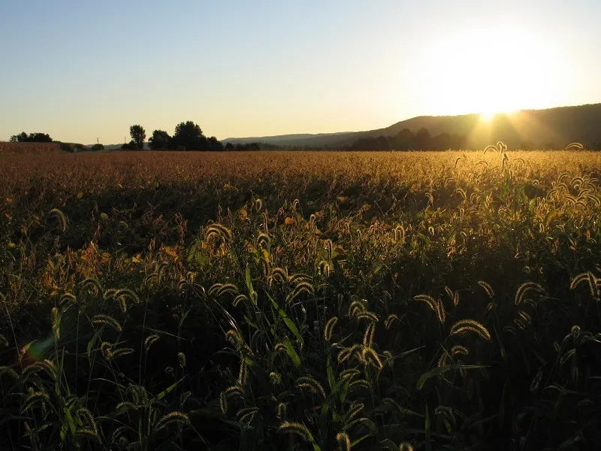
Potential Risks:
- Pollution - Air/water/soil/noise/light
- Heavy tractor trailer and auto traffic – longer commutes on local roadways and interstates
- Significant increase in traffic accidents
- Water allocation problems/well failures
- Plummeting property values
- Toxins flowing into the Musconetcong; negative impacts to water supply serving millions of downstream customers
- Visual blight on a Federally designated “Wild & Scenic River”
- Destruction of trout/wildlife habitat
- Spoil outdoor recreation activities like hiking, fishing, and tubing down the river

For more information, visit www.skylandspreservationalliance.org

